**Nov 2015 HL P1**

**Section A**

1. Human interaction with the computer system includes a range of usability problems.
2. Define the term usability. [1]
3. Identify **two** methods that could be used to improve the accessibility of a computer

system. [2]

1. By making direct reference to the technologies used, explain how a virtual private network

(VPN) allows a travelling salesperson to connect securely to their company’s network. [4]

1. Construct a truth table for the following Boolean expression.  
     
    (A and B) nor C [3]
2. A school uses a local area network (LAN) which connects several computers and a printer to

a server and allows access to the internet.

1. Define the term server. [1]
2. Identify the different clients in this network. [1]
3. (i) Identify **one** external threat to the security of the school’s computer system. [1]  
     
     
     
   (ii) State one way to protect the computer system from the threat identified in

part (c)(i). [1]

1. A sub-program all_even() accepts a positive integer N and outputs true if all digits of N

are even, otherwise it outputs false. For example, all_even(246) outputs true and

all_even(256) outputs false.

The following algorithm is constructed for the sub-program all_even(N).

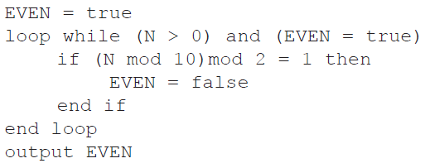

1. Explain why this algorithm does not obtain the correct result. [2]
2. Outline what should be changed in the algorithm to obtain the correct result. [3]
3. (a) Draw an annotated diagram showing how an array can be used to store a stack. [2]  
     
     
     
   (b) Explain how elements in the stack may be reversed using a queue. [4]

**Section B**

1. A hardware shop supplies a wide variety of bathroom equipment. There are 15 shop

assistants who serve customers, 3 office staff who handle the administration, and a manager.

A specialized company is asked to design and implement a new computer system for

the shop.

1. (i) Identify two different types of users of the system. [2]

(ii) Explain the role of users in the process of developing the new computer system. [3]

1. Describe why it is useful to produce more than one prototype of the new system. [2]
2. Outline two problems that may occur when transferring data from the old system to the

new system. [4]

The manager of the shop has decided to invest in a computer system which allows customers  
 to make online orders from any place at any time.

1. (i) Explain how two or more customers are able to access the computer system at

the same time. [2]

(ii) Explain how each customer’s data is secure when two customers access the  
 system at the same time. [2]

1. 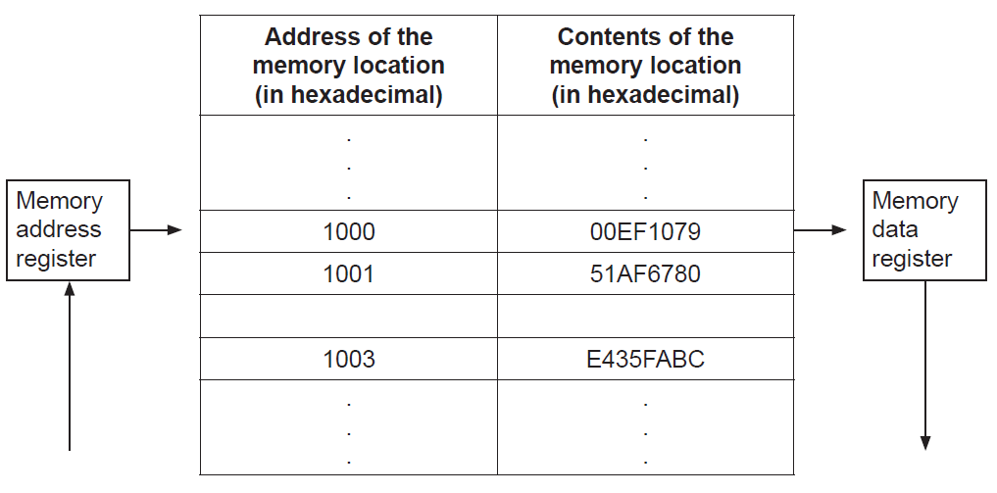The following diagram shows the structure of the random access memory (RAM).
2. Calculate the number of bits in each memory location. [1]
3. Calculate the number of bytes in each address. [1]
4. Outline the function of the:
5. memory address register [2]
6. memory data register. [2]
7. (i) Identify two functions of the operating system. [2]  
     
     
   (ii) State where the operating system is held when the computer is turned off. [1]

The machine instruction cycle refers to the retrieval of an instruction from the RAM, and  
 subsequently decoding, executing and storing the result.

1. (i) Construct a diagram to illustrate the structure of a central processing unit (CPU),

clearly showing the flow of data within the CPU. [4]

(ii) Identify the part of the CPU which performs decoding. [1]

(iii) Identify the part of the CPU which executes the instruction. [1]

1. A control system is used to control sliding doors which automatically open to allow people in

and out of a shop.

1. (i) Identify one type of sensor in this system. [1]

(ii) Identify one piece of hardware, other than sensors, that is part of the control  
 system. [1]

(iii) With reference to the role of sensors, outline the sequence of steps within the  
 computer control system that will take place when a person approaches the door. [3]

1. (i) Define the term interrupt. [2]  
     
     
     
   (ii) Describe a situation in this system where an interrupt would occur. [2]
2. Discuss the contribution of computer control systems in industry where they replace

human workers. [6]

1. 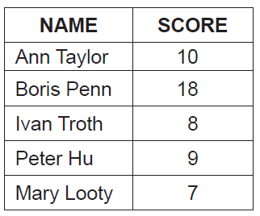The table below holds student names and scores, from a class test.
2. Draw a diagram to show how the data given in the table could be stored in a binary tree

in the order of scores. Data should be inserted into the binary tree in the order given in

the table (ie data about Ann Taylor is to be inserted first). [3]

1. The same data could be inserted into a singly linked list in descending order of scores.

Draw a diagram of this singly linked list. [3]

1. Compare the data structures in part (a) and part (b) in terms of:  
     
   (i) searching [2]  
     
     
     
   (ii) storage requirements. [2]
2. 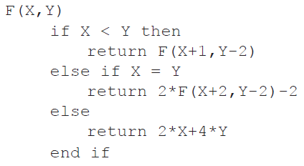Consider the following **recursive** algorithm, in which X and Y are parameters in the  
   method F. The return statement gives the value that the method generates.  
     
     
     
     
     
     
     
     
     
   Determine the value of F(5,11). [5]
3. A population study divides a metropolitan area into seven regions: A–G.

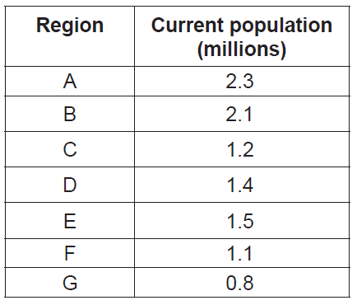The following table shows the current population (in millions) of the regions.

Two one-dimensional arrays, Region and Curr_Pop, are used to hold this data.

For example, Region[0] ='A'. The population in region A is 2.3 million and 2.3 is found in

Curr_Pop[0].

1. Construct the algorithm that will output the total population in the metropolitan area. [3]

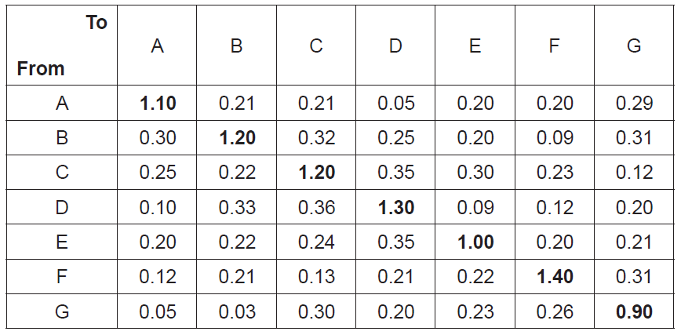 The numbers in the following table represent expected percentages of yearly migration from  
 one region to another, obtained by analysing historical migration data. For example, it is  
 expected that 0.32 % of the current population of region B will move to region C.  
 The diagonal entries represent a region’s internal growth rate. For example, the population  
 of region C is expected to increase by 1.2 % as a result of the births and deaths of people  
 currently living in region C.

1. (i) State the percentage of the population of region G that are expected to move to

region A. [1]

(ii) Determine the number of people from region B who are expected to move to  
 region E. [1]

(iii) Describe how the change in population of region F in one year could be

determined. [3]

1. Construct the algorithm that will predict the population in each region after 10 years.

You should assume that the yearly migration percentages, given in the table on page 8,

remain the same over the 10 years. [7]